

**The Polytechnic School**

Sutton Hall, Suite 140

6049 S Backus Mall

Mesa, AZ 85212

(480) 727-1177

Fax: (480) 727-2886

poly.engineering.asu.edu

**IFT 365 – Applied Programming Language for Information Technology**

**Coding Project – Project Update 2**

**Name: Brandon Trinkle**

**ASU ID: 1217455031**

**Date: 11/17/2024**

**Instructions:** You should have at least **six features or functions of your applications completed** by the time you submit this assignment. Use the questions below to have a written discussion about the current progress of your coding project. After you answer the questions below, insert a screenshot of the features or functions you have completed so far.

1. How do you feel your coding project is coming along?

It is coming along much better this week. I am just about completed with the project, I have 2 more features to integrate and it is completed. I’ve added some helper functions and more directories to organize the code better.

1. Since your last update, what issues have you encountered? Have you already resolved them? How? If not, how do you plan to resolve them?

I don’t have any new issues, still working through appending new data entries to the csv file, and generating an automated report.

1. Your coding project is almost done. Outline what you have left and how you plan on completing it.

I have 2 more features to complete.

1. Automated reports
   1. Storing locally (PDF w/ network stats)
2. Appending csv file to only hold 2 hrs worth of networks stats.

I plan to complete these by the end of the thanksgiving break.

1. With your application almost done, has your flow chart changed? If so, revise your previous flow chart and insert it below.

It has not changed since the last update.

----------completed-----------

1. Run ookla for network stats
2. Store data in csv file
3. Generate visual representation of stats

----------in progress----------

1. Append csv file for most recent 2 hours of stats
2. Generate Report every 2 hours for network stats
3. Insert the screenshot(s) of feature or function #1 here.

Program running - 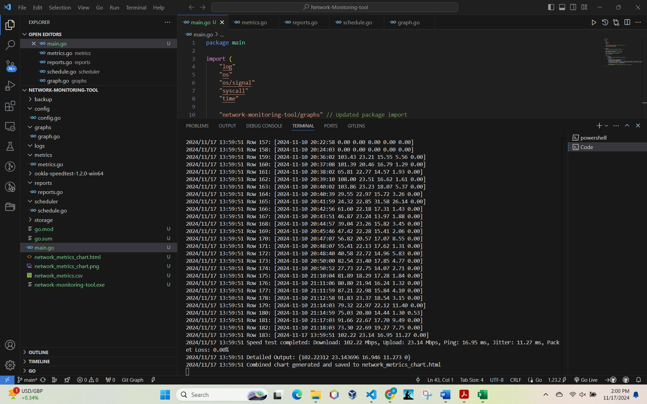

1. Insert the screenshot(s) of feature or function #2 here.

CSV file –

1. Insert the screenshot(s) of feature or function #3 here.

Data visualization

